**Lab 4  
Unit Testing**

* Write code and unit test with Junit, based on the demo project.

Use the given Template for unit testing, you need complete the following tasks:

**Function 1**: Assuming you are assigned to conduct the component test for the method below, please design and create the minimum component test case (unit test case) needed to achieve 100% statement coverage and 100% decision coverage.

This code defines a performOperation method that takes two numbers and an operation string as input. It performs the specified operation (addition, subtraction, multiplication, or division) and returns the result. It includes logging for each operation, as well as error handling for various scenarios.

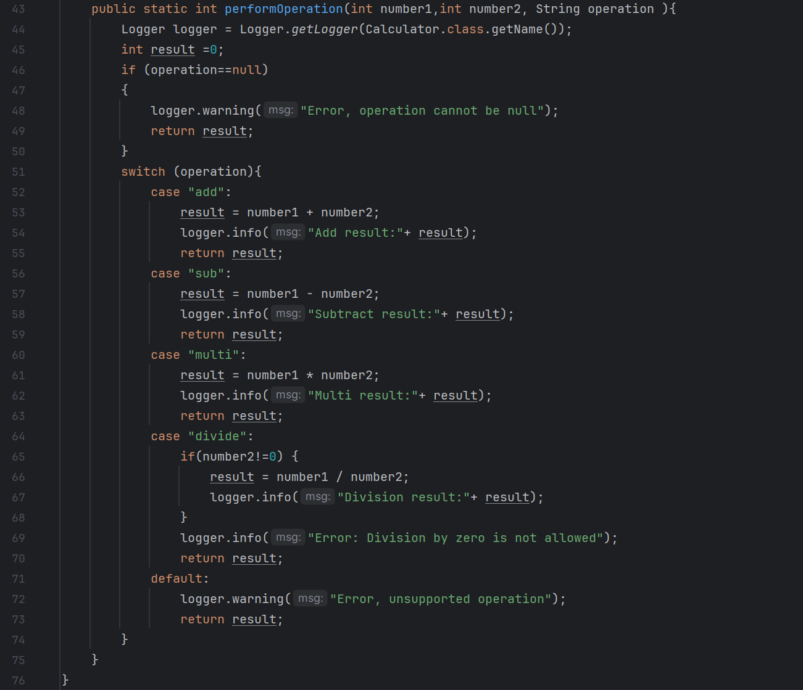

**Function 2: Register account**

**Function 3: Any function in your project**